**EL-227 Computer Logic Design- Spring 2020**

**Mini Projects Date: 16th Apr 2020**

**Important Note:**

Besides below mentioned projects the students self-proposed ideas would be equally appreciated, provided they are in accordance with the course content.



The group should consist of 2 to 4 members depending upon the scope of the project.



The proposal should be submitted in hard copy only and must be in the template discussed below.

No hand written and emailed proposal will be accepted



The students are advice to start working on the project soon after the proposal approval. The project assignment will be on first come first serve basis.

Exact one month will be given to complete the project.

Date for viva and submission of project along with report will be announced later.

**Deadline for Proposal Submission is Thursday, 29th March, 2020**



**Proposal Submit Soft Copy on Google Class Room Only**

**Proposal Pattern:**

***The proposal should be written in the following format***

1. ***Group member’s names & Roll numbers***
2. Ashmal Anis (19k-0305)
3. Hasnain Somani (19k-0204)
4. Abdul Samad (19k-1396)
5. ***Project’s objective (one line)***

The objective of project is to implement some basic functions of the digital clock which we use in daily like including displaying time (hours, minutes, and seconds)

1. ***Components used (list of important components and ICs used in the Project)***
2. OR Gate
3. IC 7490 Binary Decade Counter
4. IC 7447 BCD to Seven Segment Display
5. Resistors
6. Function Generators
7. Switches/keys
8. Batteries
9. ***Circuit Diagram***

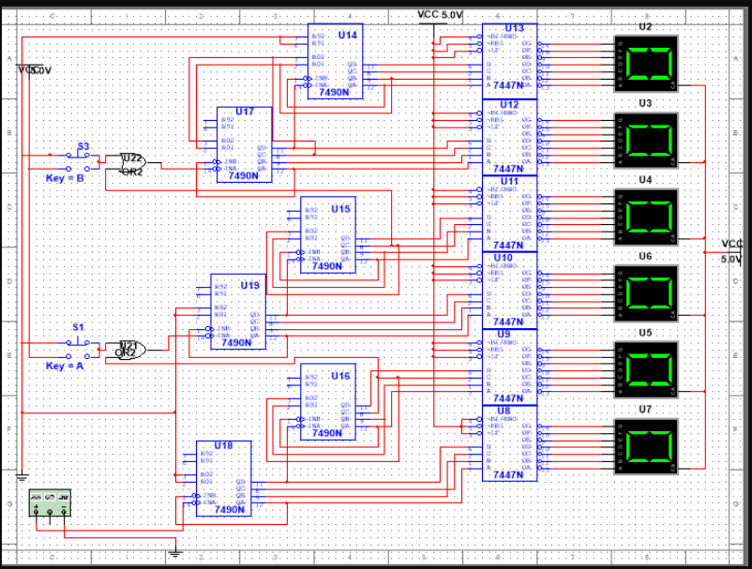

***5- Abstract, including brief description of your project along with the areas/ topics/ concepts the project is going to cover. (At least two to three lines and at most one paragraph.***

We are making a digital clock which uses some concepts like implementation of logic gates, working of IC’s including converts like BCD to seven segment displays and furthermore. The clock will display time in 24 hour format (hours, minutes, and seconds) to ensure accuracy. Multiple IC’s are used for efficient output with systematic input from switches and batteries.